窗体顶端

### USE CASE DIAGRAM: AN ONLINE BOOKSTORE.

#### ****1. Use Case Diagrams****

A **use case diagram** visually represents how users (actors) interact with the system. It defines the scope and the interactions between the system's functional components and its users.

In an online bookstore, common actors and use cases include:

##### ****Actors:****

* **Customer**: A person who browses, selects, and purchases books.
* **Admin**: Manages book inventory, reviews orders, and handles customer issues.
* **Payment Gateway**: External system for processing payments

**Customer**: A regular user who visits the online bookstore to buy books.

* **Browse Books**: Looking through different book categories.
* **Search Books**: Finding books by title, author, or keywords.
* **View Book Details**: Checking out information like author, price, reviews, and description.
* **Add to Cart**: Selecting a book to put in the shopping cart.
* **Manage Cart**: Editing the items in the cart before purchasing.
* **Checkout**: Confirming the purchase by providing shipping and payment details.
* **Register/Log In**: Creating an account for a personalized experience or logging in if already registered.
* **View Purchase History**: Seeing past orders.
* **Rate and Review Books**: Writing reviews for purchased books.

**Admin**: Manages the bookstore's content and operations.

* **Manage Book Inventory**: Adding, updating, or deleting books from the catalog.
* **Manage Orders**: Viewing, approving, or shipping customer orders.
* **Manage Customer Queries**: Handling customer issues and questions.

**Payment Gateway**: An external service that helps process payments when customers checkout.

##### ****Primary Use Cases for an Online Bookstore:****

1. **Browse Books**: The customer browses available books by category or author.
2. **Search Books**: The customer searches for books using keywords.
3. **View Book Details**: The customer views the details (title, author, price, reviews) of a selected book.
4. **Add to Cart**: The customer adds a selected book to their cart.
5. **Manage Cart**: The customer updates their cart by adding/removing books.
6. **Checkout**: The customer initiates the purchase by providing shipping and payment details.
7. **Make Payment**: The system integrates with a payment gateway to complete the purchase.
8. **Manage Orders**: Admin views and manages orders (approve, reject, or ship orders).
9. **Update Book Inventory**: Admin adds, updates, or removes books from the catalog.
10. **Manage Customer Queries**: Admin manages customer queries or issues.

##### ****Extended Use Cases:****

* **Register/Log In**: Customer registers or logs into the system for a personalized experience.
* **View Purchase History**: Customer views previous orders.
* **Rate and Review Book**: Customer submits ratings and reviews for a purchased book.

#### ****2. Sequence Diagrams****

A **sequence diagram** shows how processes operate with one another and in what order. It helps describe the detailed flow of interaction between system components and actors for each use case.

For each functional component, we can define its respective sequence diagram. Let’s focus on the primary components in an online bookstore:

##### ****1. Browse Books (Sequence Diagram)****

* **Actors**: Customer, Book Catalog
* **Steps**:
  1. Customer opens the bookstore website.
  2. The system fetches available categories and popular books.
  3. Customer selects a category to browse.
  4. System fetches and displays the list of books in the selected category.

##### ****2. Add to Cart (Sequence Diagram)****

* **Actors**: Customer, Cart, Book Catalog
* **Steps**:
  1. Customer selects a book to view its details.
  2. System fetches and displays the book details.
  3. Customer clicks "Add to Cart".
  4. System adds the selected book to the cart.

##### ****3. Checkout (Sequence Diagram)****

* **Actors**: Customer, Cart, Payment Gateway, Order Management
* **Steps**:
  1. Customer clicks on "Checkout" to begin.
  2. System displays the cart summary and requests shipping information.
  3. Customer enters shipping details.
  4. System confirms the order and redirects to payment.
  5. Customer selects a payment method, and the system integrates with the payment gateway.
  6. Payment is processed and confirmed by the system.
  7. Order is stored in the Order Management system and confirmation is sent to the customer.

##### ****4. Manage Orders (Admin Sequence Diagram)****

* **Actors**: Admin, Order Management, Book Catalog
* **Steps**:
  1. Admin logs into the system.
  2. The system displays the list of pending orders.
  3. Admin selects an order to view the details.
  4. Admin approves or rejects the order.
  5. System updates the order status and adjusts the inventory.

窗体顶端

窗体底端

窗体底端

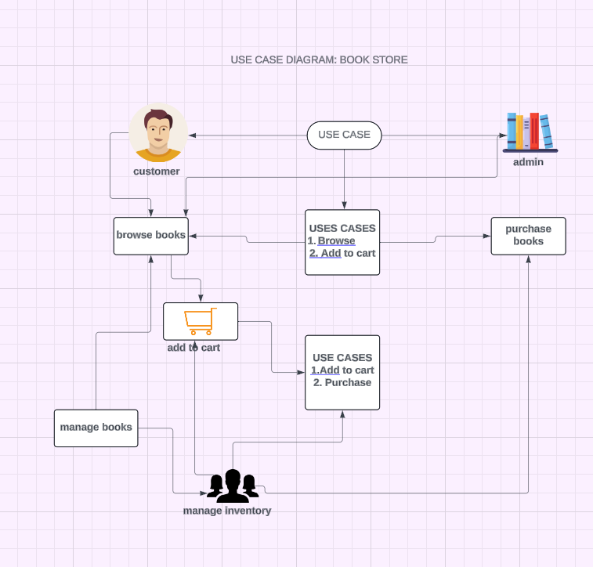

Use case diagram

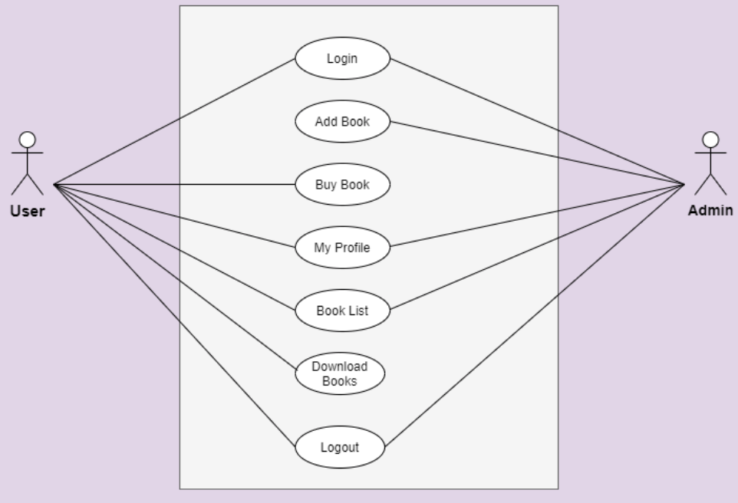usecase diagram

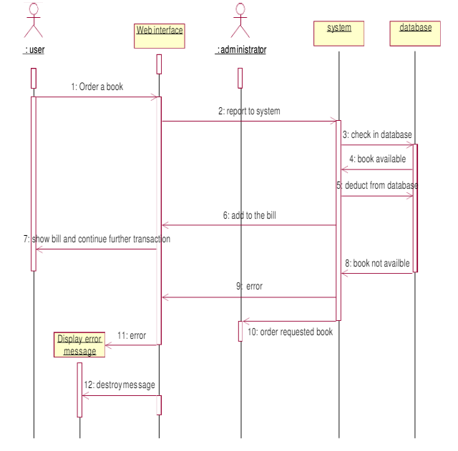sequence diagram